Q1 - Banking System: Constructor Demo (Default, Parameterized, Copy)
#include<iostream>
#include<cstring>
using namespace std;

class Account {
private:
int accNo;
char* holderName;
double balance;
public:
Account() {
accNo=0;
holderName=new char[1];
holderName[0]='\0';
balance=0.0;
cout<<"[Default Constructor] called"<<endl;
}
Account(int no, const char* name, double bal) {
accNo=no;
holderName=new char[strlen(name)+1];
strcpy(holderName,name);
balance=bal;
cout<<"[Parameterized Constructor] called for "<<holderName<<endl;
}
Account(const Account& other) {
accNo=other.accNo;
holderName=new char[strlen(other.holderName)+1];
strcpy(holderName,other.holderName);
balance=other.balance;
cout<<"[Copy Constructor] called for "<<holderName<<endl;
}
~Account() {
cout<<"[Destructor] called for "<<holderName<<endl;
delete[] holderName;
}
void display() const {
cout<<"AccNo: "<<accNo<<" | Name: "<<holderName<<" | Balance: "<<balance<<endl;
}
};

int main() {
cout<<"=== Banking Constructor Demo ==="<<endl;
cout<<"\n-- Creating default account --"<<endl;
Account a1;
a1.display();

cout<<"\n-- Creating parameterized account --"<<endl;
Account a2(101,"Ravi Kumar",5000.50);
a2.display();

cout<<"\n-- Creating copy from a2 --"<<endl;
Account a3=a2;
a3.display();

cout<<"\n-- End of main, destructors fire in reverse order --"<<endl;
return 0;}

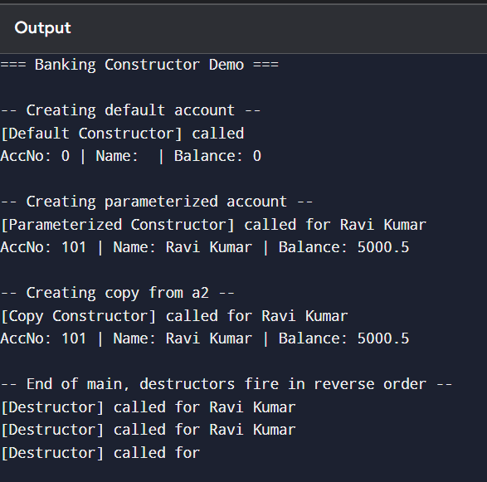
Q2 - Inventory Management: Product Class (Copy Constructor, Destructor, Operator+)
#include<iostream>
#include<cstring>
using namespace std;

class Product {
private:
int productId;
char* name;
int quantity;
public:
Product(int id, const char* pname, int qty) {
productId=id;
name=new char[strlen(pname)+1];
strcpy(name,pname);
quantity=qty;
cout<<"[Parameterized Constructor] Product "<<name<<" created with qty "<<quantity<<endl;
}
Product(const Product& other) {
productId=other.productId;
name=new char[strlen(other.name)+1];
strcpy(name,other.name);
quantity=other.quantity;
cout<<"[Copy Constructor] Product "<<name<<" duplicated with qty "<<quantity<<endl;
}
~Product() {
cout<<"[Destructor] Product "<<name<<" destroyed, memory released"<<endl;
delete[] name;
}
Product operator+(const Product& other) const {
cout<<"[Operator+] Combining "<<name<<" and "<<other.name<<endl;
Product combined(productId,name,quantity+other.quantity);
return combined;
}
void display() const {
cout<<"ID: "<<productId<<" | Name: "<<name<<" | Quantity: "<<quantity<<endl;
}
};

int main() {
cout<<"=== Inventory Management Demo ==="<<endl;

cout<<"\n-- Creating original product --"<<endl;
Product p1(1,"Notebook",50);
p1.display();

cout<<"\n-- Duplicating product (copy constructor) --"<<endl;
Product p2=p1;
p2.display();

cout<<"\n-- Creating second product for combination --"<<endl;
Product p3(1,"Notebook",30);
p3.display();

cout<<"\n-- Combining stock using operator+ --"<<endl;
Product combined=p1+p3;
combined.display();

cout<<"\n-- End of main, destructors fire for all objects in reverse order --"<<endl;
return 0;
}

Q3 - Shopping Cart: Object Lifecycle and Cart Merging (Operator+)
#include<iostream>
#include<cstring>
using namespace std;

class ShoppingCart {
private:
char* cartName;
int* items;
int itemCount;
public:
ShoppingCart(const char* name, int* products, int count) {
cartName=new char[strlen(name)+1];
strcpy(cartName,name);
itemCount=count;
items=new int[itemCount];
for(int i=0;i<itemCount;i++) items[i]=products[i];
cout<<"[Parameterized Constructor] Cart "<<cartName<<" created with "<<itemCount<<" items"<<endl;
}
ShoppingCart(const ShoppingCart& other) {
cartName=new char[strlen(other.cartName)+1];
strcpy(cartName,other.cartName);
itemCount=other.itemCount;
items=new int[itemCount];
for(int i=0;i<itemCount;i++) items[i]=other.items[i];
cout<<"[Copy Constructor] Cart "<<cartName<<" duplicated with "<<itemCount<<" items"<<endl;
}
~ShoppingCart() {
cout<<"[Destructor] Cart "<<cartName<<" cleared, memory released"<<endl;
delete[] items;
delete[] cartName;
}
ShoppingCart operator+(const ShoppingCart& other) const {
cout<<"[Operator+] Merging "<<cartName<<" and "<<other.cartName<<endl;
int total=itemCount+other.itemCount;
int* merged=new int[total];
for(int i=0;i<itemCount;i++) merged[i]=items[i];
for(int i=0;i<other.itemCount;i++) merged[itemCount+i]=other.items[i];
ShoppingCart result("MergedCart",merged,total);
delete[] merged;
return result;
}
void display() const {
cout<<cartName<<" -> Items: ";
for(int i=0;i<itemCount;i++) cout<<items[i]<<" ";
cout<<"| Total Items: "<<itemCount<<endl;
}
};

int main() {
cout<<"=== Shopping Cart Demo ==="<<endl;

int p1[]={101,102,103};
int p2[]={201,202};

cout<<"\n-- Creating cart1 --"<<endl;
ShoppingCart cart1("Cart1",p1,3);
cart1.display();

cout<<"\n-- Creating cart2 --"<<endl;
ShoppingCart cart2("Cart2",p2,2);
cart2.display();

cout<<"\n-- Duplicating cart1 (copy constructor) --"<<endl;
ShoppingCart cart1Copy=cart1;
cart1Copy.display();

cout<<"\n-- Merging cart1 and cart2 using operator+ --"<<endl;
ShoppingCart merged=cart1+cart2;
merged.display();

cout<<"\n-- End of main, destructors fire for all objects in reverse order --"<<endl;
return 0;
}

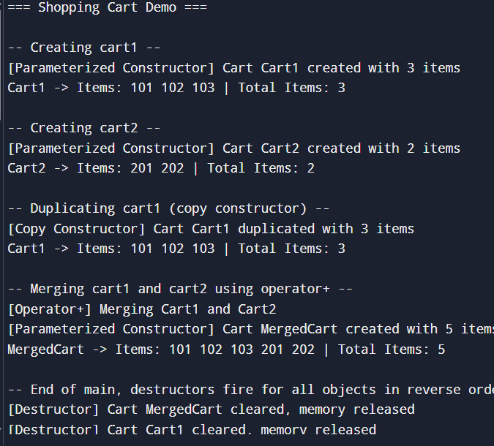

Q4 - Retail Product: Parameterized, Copy, Dynamic Constructor, Destructor, Operator+
#include<iostream>
#include<cstring>
using namespace std;

class Product {
private:
int productId;
char* name;
int quantity;
public:
Product(int id, const char* pname, int qty) {
productId=id;
name=new char[strlen(pname)+1];
strcpy(name,pname);
quantity=qty;
cout<<"[Parameterized Constructor] "<<name<<" created (ID:"<<productId<<", Qty:"<<quantity<<")"<<endl;
}
Product(const Product& other) {
productId=other.productId;
name=new char[strlen(other.name)+1];
strcpy(name,other.name);
quantity=other.quantity;
cout<<"[Copy Constructor / Deep Copy] "<<name<<" duplicated (ID:"<<productId<<", Qty:"<<quantity<<")"<<endl;
}
Product(int id, int nameLength, int qty) {
productId=id;
name=new char[nameLength+1];
for(int i=0;i<nameLength;i++) name[i]='X';
name[nameLength]='\0';
quantity=qty;
cout<<"[Dynamic Constructor] Allocated "<<nameLength<<" chars for product name, ID:"<<productId<<endl;
}
~Product() {
cout<<"[Destructor] "<<name<<" (ID:"<<productId<<") destroyed, memory released"<<endl;
delete[] name;
}
Product operator+(const Product& other) const {
cout<<"[Operator+] Combining quantities of "<<name<<" and "<<other.name<<endl;
return Product(productId,name,quantity+other.quantity);
}
void display() const {
cout<<"ID: "<<productId<<" | Name: "<<name<<" | Quantity: "<<quantity<<endl;
}
};

int main() {
cout<<"=== Retail Product Lifecycle Demo ==="<<endl;

cout<<"\n-- Step 1: Create product (Parameterized Constructor) --"<<endl;
Product p1(501,"Wireless Mouse",100);
p1.display();

cout<<"\n-- Step 2: Copy product for stock transfer (Copy Constructor, deep copy) --"<<endl;
Product p2=p1;
p2.display();

cout<<"\n-- Step 3: Create another product to add quantities --"<<endl;
Product p3(501,"Wireless Mouse",50);
p3.display();

cout<<"\n-- Step 4: Combine quantities using operator+ --"<<endl;
Product combined=p1+p3;
combined.display();

cout<<"\n-- Step 5: Dynamic constructor (allocate name buffer separately) --"<<endl;
Product p4(502,8,20);
p4.display();

cout<<"\n-- End of main, destructors fire for all objects in reverse order --"<<endl;
return 0;
}

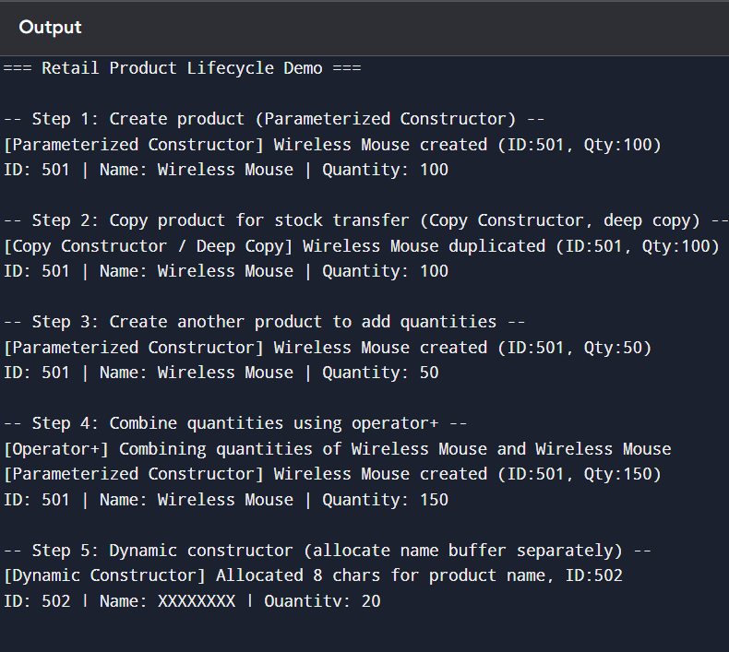

Q5 - Banking System: Constructor Overloading and Operator Overloading (+ / -)
#include<iostream>
#include<cstring>
using namespace std;

class Account {
private:
int accNo;
char* holderName;
double balance;
public:
Account() {
accNo=0;
holderName=new char[1];
holderName[0]='\0';
balance=0.0;
cout<<"[Default Constructor] called"<<endl;
}
Account(int no) {
accNo=no;
holderName=new char[1];
holderName[0]='\0';
balance=0.0;
cout<<"[AccNo-only Constructor] called for account "<<accNo<<endl;
}
Account(int no, const char* name, double bal) {
accNo=no;
holderName=new char[strlen(name)+1];
strcpy(holderName,name);
balance=bal;
cout<<"[Full-detail Constructor] called for "<<holderName<<endl;
}
Account(const Account& other) {
accNo=other.accNo;
holderName=new char[strlen(other.holderName)+1];
strcpy(holderName,other.holderName);
balance=other.balance;
cout<<"[Copy Constructor] log entry created for "<<holderName<<endl;
}
~Account() {
cout<<"[Destructor] account "<<accNo<<" closed, memory released"<<endl;
delete[] holderName;
}
Account operator+(double amount) const {
cout<<"[Operator+] Depositing "<<amount<<" into account "<<accNo<<endl;
Account result(*this);
result.balance+=amount;
return result;
}
Account operator-(double amount) const {
cout<<"[Operator-] Withdrawing "<<amount<<" from account "<<accNo<<endl;
Account result(*this);
if(amount>result.balance) {
cout<<" Insufficient balance, withdrawal denied"<<endl;
return result;
}
result.balance-=amount;
return result;
}
void display() const {
cout<<"AccNo: "<<accNo<<" | Name: "<<holderName<<" | Balance: "<<balance<<endl;
}
};

void passByValue(Account acc) {
cout<<"[Inside passByValue] received copy:"<<endl;
acc.display();
}

Account returnAccount() {
Account temp(303,"Temp Holder",1000);
return temp;
}

int main() {
cout<<"=== Banking Operator Overloading Demo ==="<<endl;

cout<<"\n-- Default constructor --"<<endl;
Account a1;
a1.display();

cout<<"\n-- AccNo-only constructor --"<<endl;
Account a2(202);
a2.display();

cout<<"\n-- Full-detail constructor --"<<endl;
Account a3(101,"Anita Sharma",10000);
a3.display();

cout<<"\n-- Deposit using operator+ --"<<endl;
Account a4=a3+2000;
a4.display();

cout<<"\n-- Withdraw using operator- --"<<endl;
Account a5=a4-3000;
a5.display();

cout<<"\n-- Pass by value (copy constructor called) --"<<endl;
passByValue(a3);

cout<<"\n-- Return from function (copy/move on return) --"<<endl;
Account a6=returnAccount();
a6.display();

cout<<"\n-- End of main, destructors fire for all objects in reverse order --"<<endl;
return 0;
}

